Best Free Shopify Apps: 15 Best for 2023
Would you like to know how to improve your Shopify store? Look no further! There are many free Shopify apps available that can help you optimize your store and boost sales.
From marketing and SEO tools to email automation and loyalty programs, these top free Shopify apps will help you get great output from your store and make more money.
These apps can manage your inventory to create promotions and track performance. You can make your store more efficient and successful without spending much money.
Take a look at the 15 best free Shopify apps at the Shopify app store for 2023 and scale your business.

15 Best Free Shopify Apps for 2023

Easy Digital Product
Easy Digital Product by Shopify is a powerful app that lets you quickly and easily sell digital products from your Shopify store. This app enables you to easily create simple, secure digital product listings and manage your digital products.
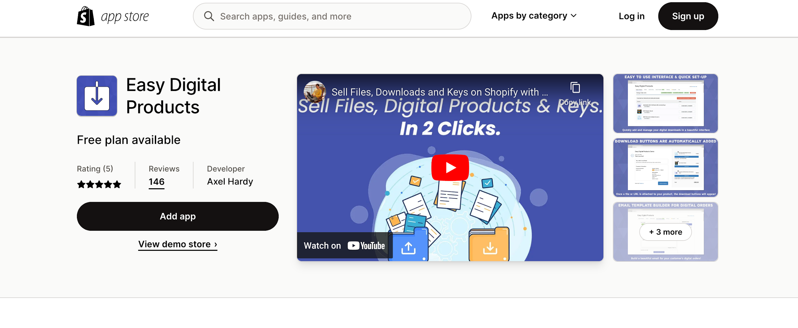
Here, you can easily upload and manage files, set prices for your products, and enable customers to purchase and download digital products from your store. Easy Digital Product also offers a range of additional features to help you maximize your digital product sales.
You can create product bundles, customize download bundles, upsells, and cross-sells to increase your revenue. Plus, you can also protect your products with a fantastic feature called the advanced license keys feature. There are also PDF Stamping, API, SMTP, and download limits features that you can use.

Automizely Email&SMS Marketing
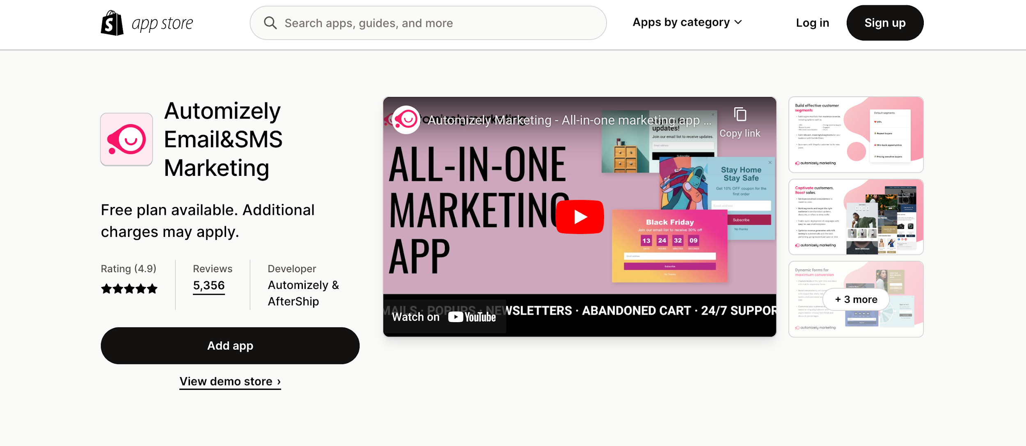
Automizely helps online stores maintain operations and grow their business. It enables stores to automate their marketing activities and functions, saving time and money.
The app simplifies creating, launching, and managing campaigns, making it easier for merchants to increase sales.
It also provides insights into customer behavior, enabling merchants to make better decisions about their campaigns and strategies. This app offers a range of features and tools to help merchants increase the reach of their campaigns and optimize their systems.
These include-
- Marketing automation
- Audience segmentation,
- A/B testing,
- Push notifications,
- Dynamic content optimization, and more.
You will also get comprehensive reporting and analytics, allowing merchants to track their performance and make informed decisions through this app.
Overall, Automizely is an invaluable tool for Shopify merchants looking to increase sales and optimize their operations.

EasyShip- All in One Shipping
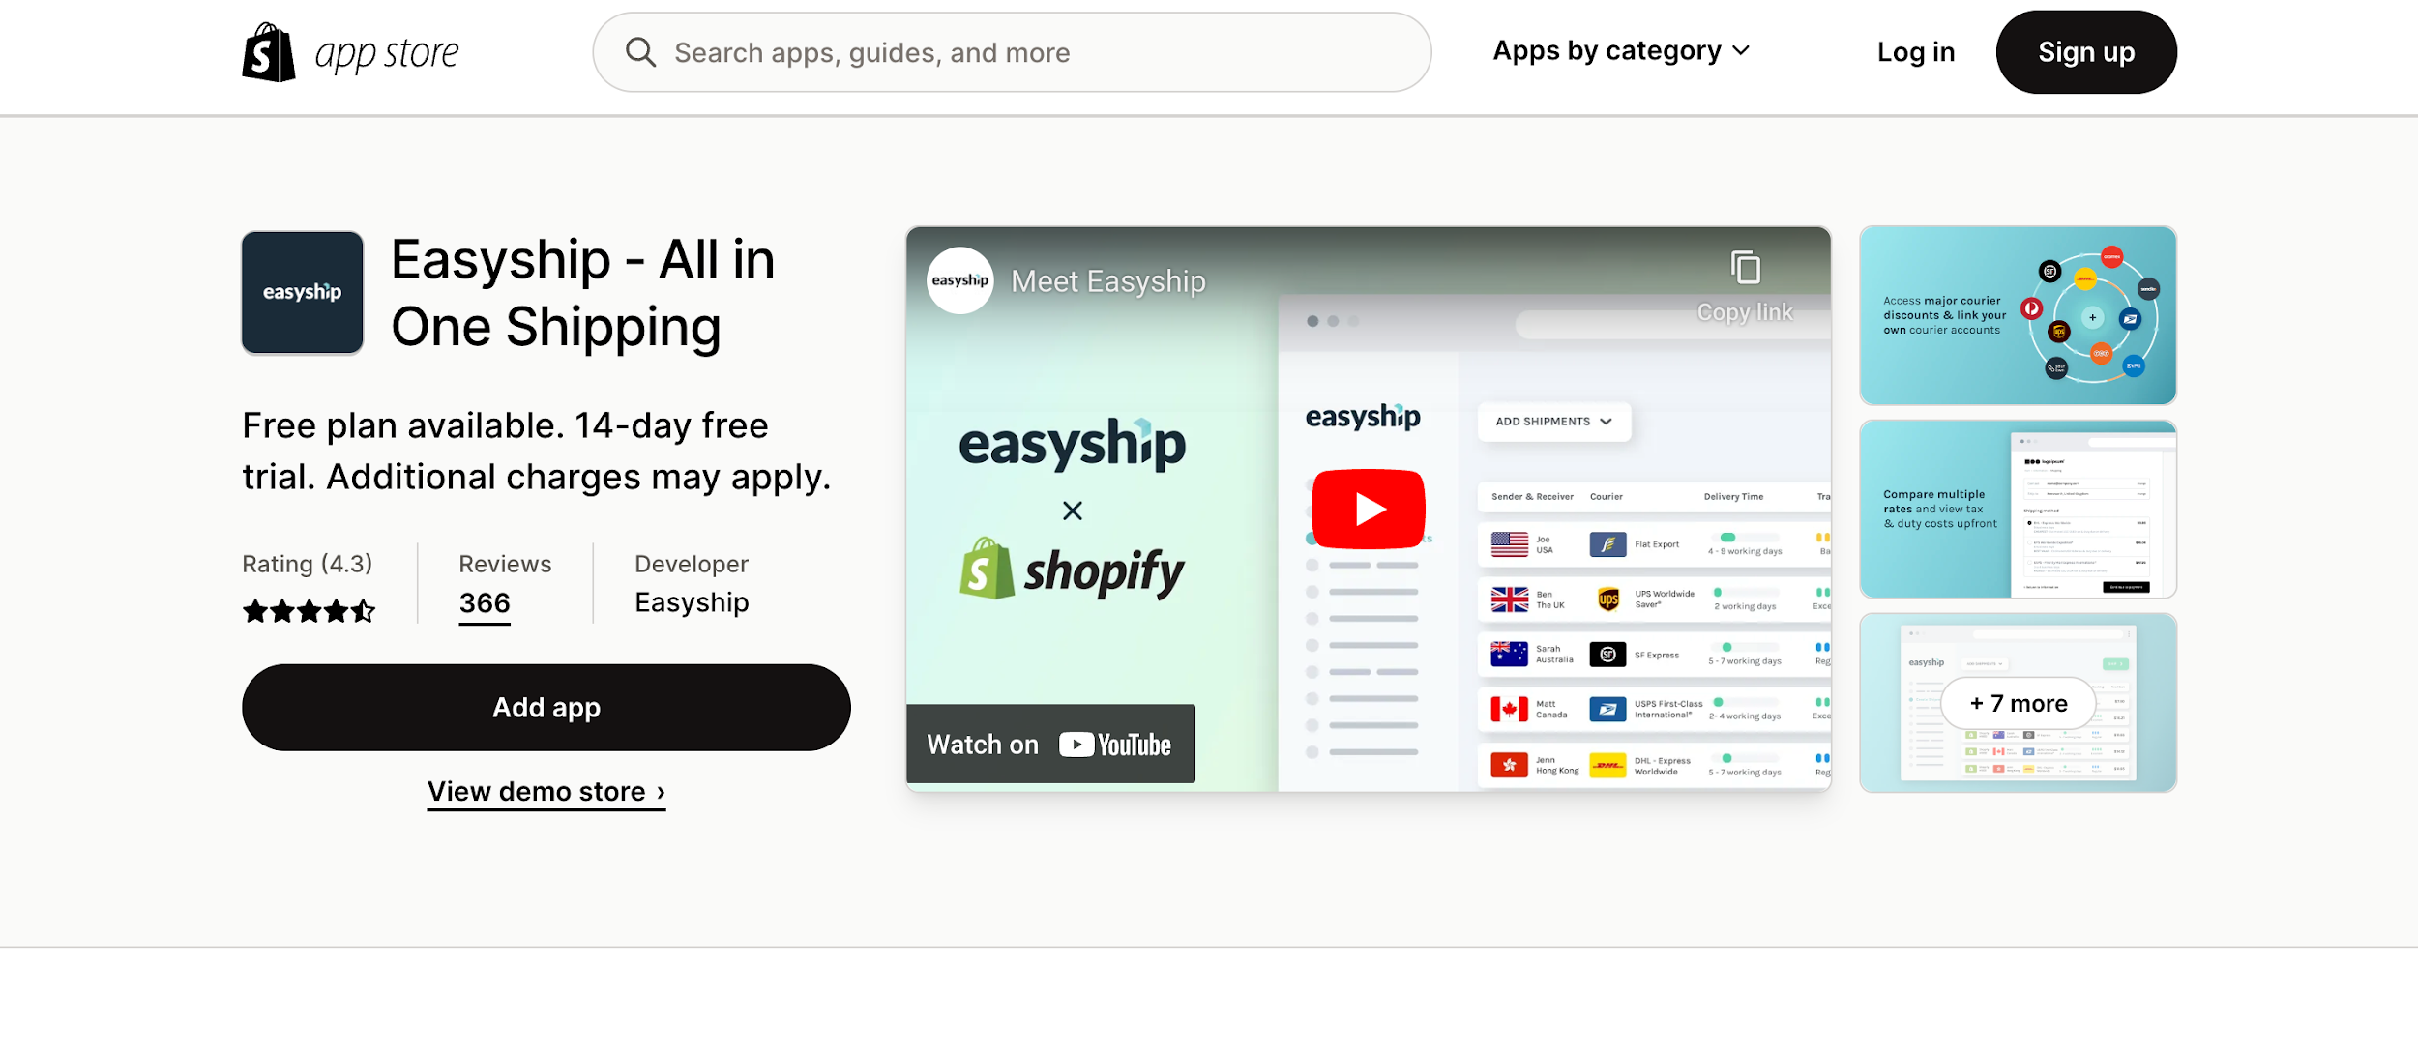
EasyShip automates the shipping process for merchants. It is an all-in-one shop for your shipping solution.
The app offers real-time shipping rates from over 100 global carriers, including USPS, UPS, DHL, and FedEx. It allows you to integrate with Shopify's order management system, allowing merchants to manage orders and track shipments easily.
You can also get the privilege of getting proactive updates on your customers' orders, keeping them informed every step of the way. Additionally, merchants can access analytics to track and optimize their shipping performance.
The design of this app shows merchants a comprehensive and streamlined shipping experience. The free service includes 50 shipments, integration with unlimited sales channels, email service, and calculation of import tax and duty with documentation.

Offset
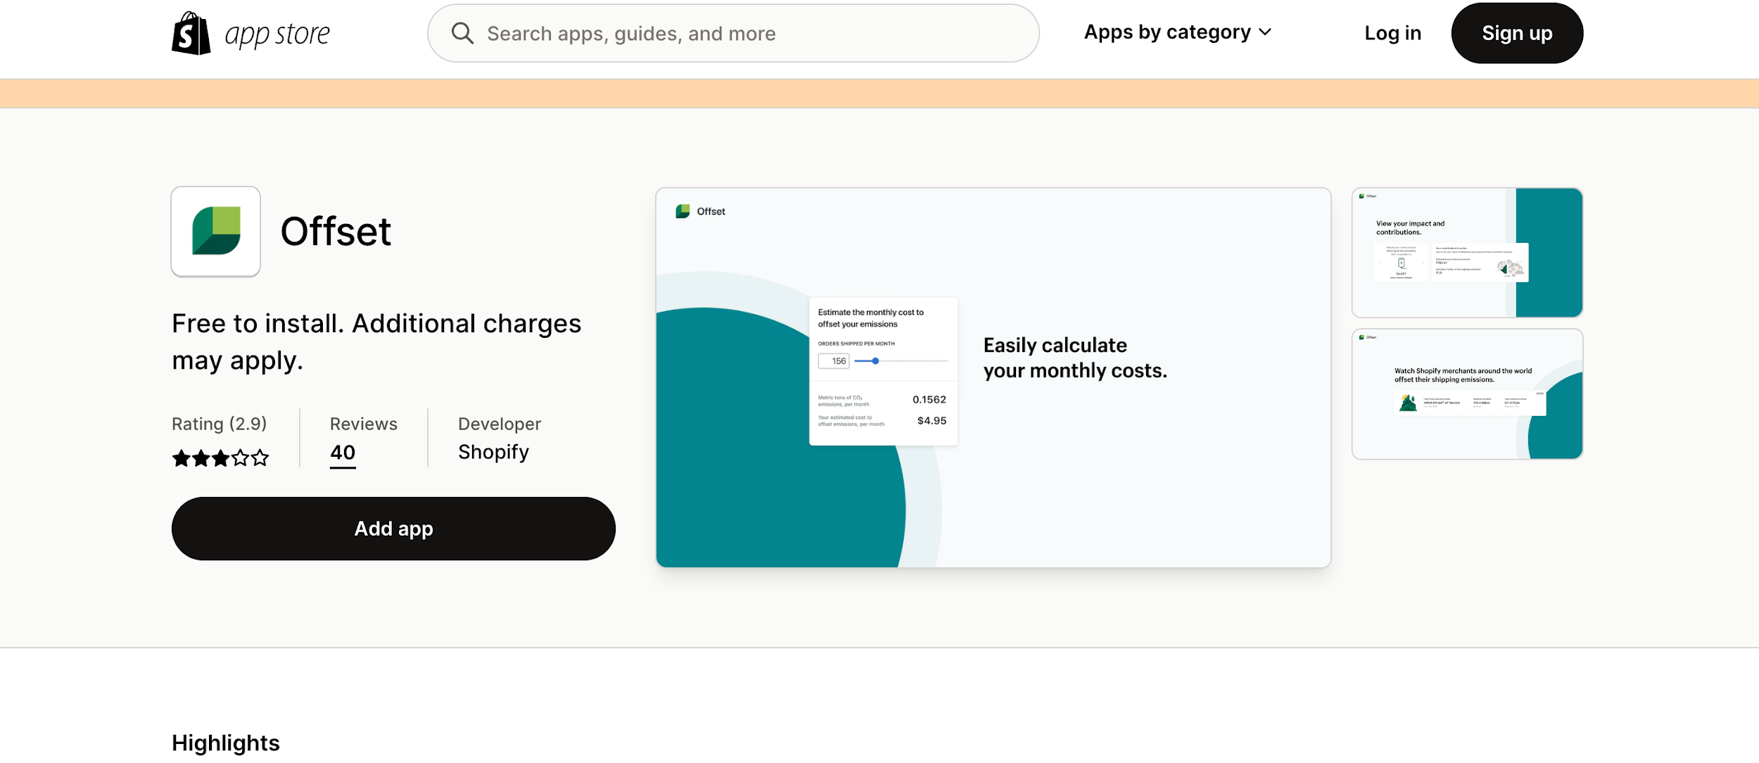
Offset is a Shopify app that allows businesses to offer their customers an easy, cost-effective way to offset their carbon emissions. It helps companies reduce their carbon footprint by automatically calculating their carbon emissions and providing customers with an easy way to balance them.
Customers can choose from various carbon offset projects, track their progress, and manage their carbon footprint.
This app is simple, and companies can quickly and easily use the services with just a few clicks. It is free to install and charges $0.0075 to $0.15 per order.
For emitting one metric ton of CO2, you have to pay $5.40. This money goes directly to their fund that works for forest protection.

Advoz
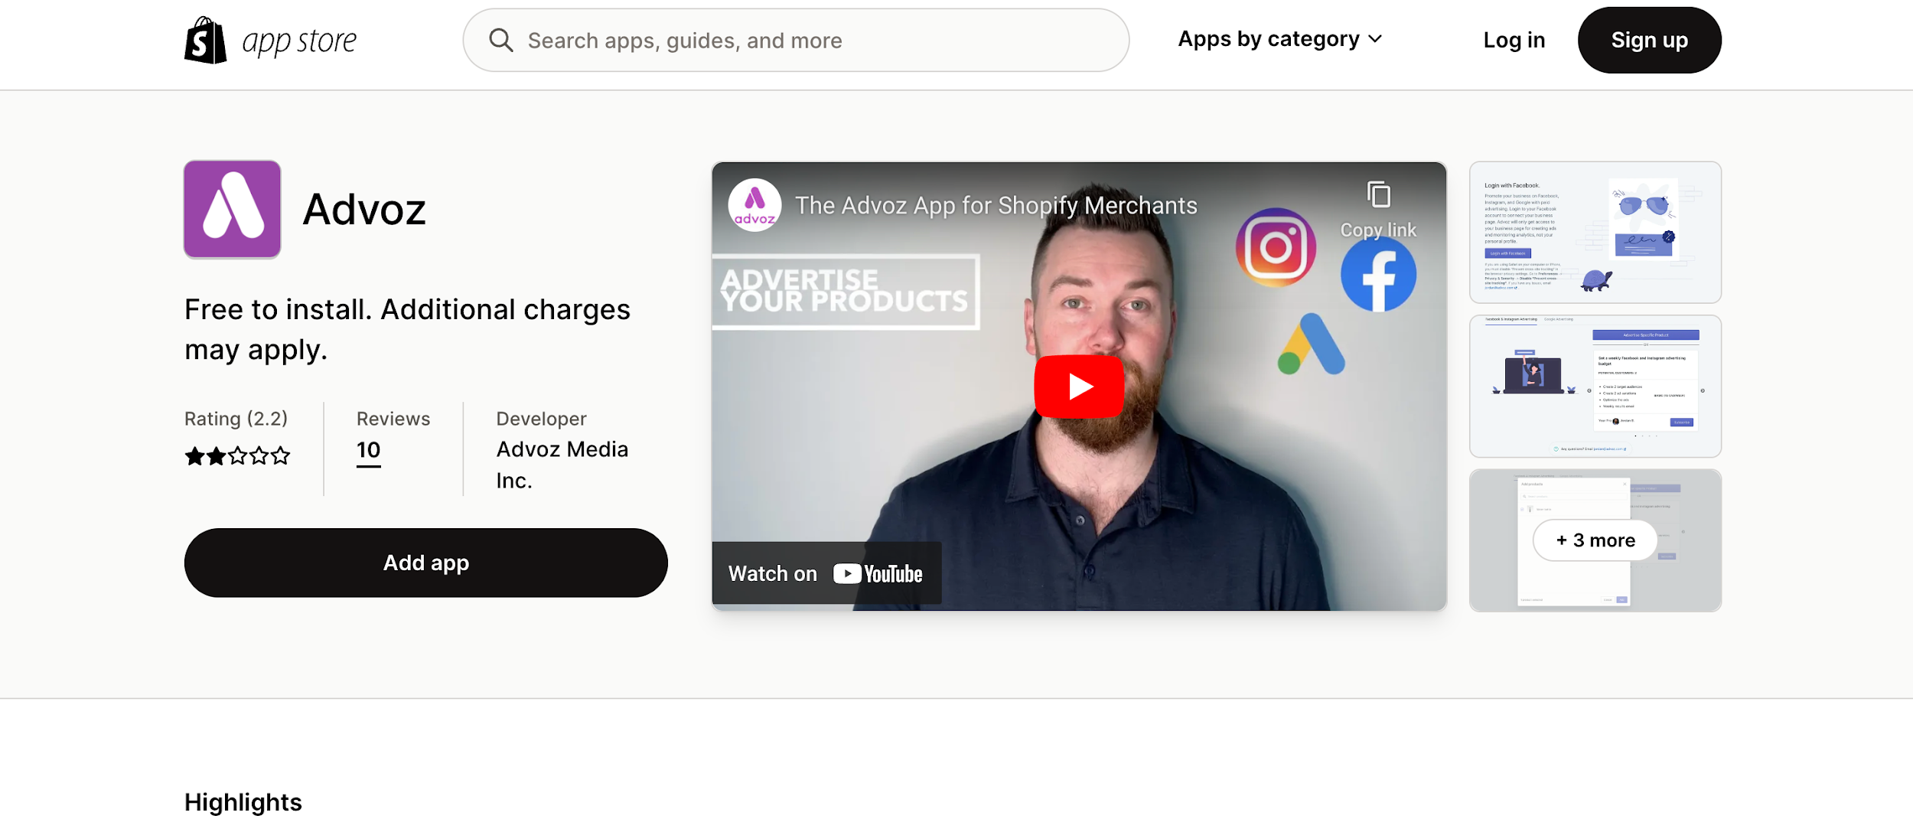
Another free Shopify app that you may find helpful is Advoz. This app helps you manage your social media handles. The social media platform is all about making content and ads.
Advoz is the best solution for creating high-quality ads for Facebook, Instagram, Google, and other social media platforms.
It is a pro advertising app that minimizes your efforts in making trendy ads. It also provides custom graphics to attract more audience and increase your store's traffic.
It is a hands-free approach to creating excellent ads to promote your business. You must log in with your Facebook Business Account to use the app.

Peek!-BetterReplay & Survey
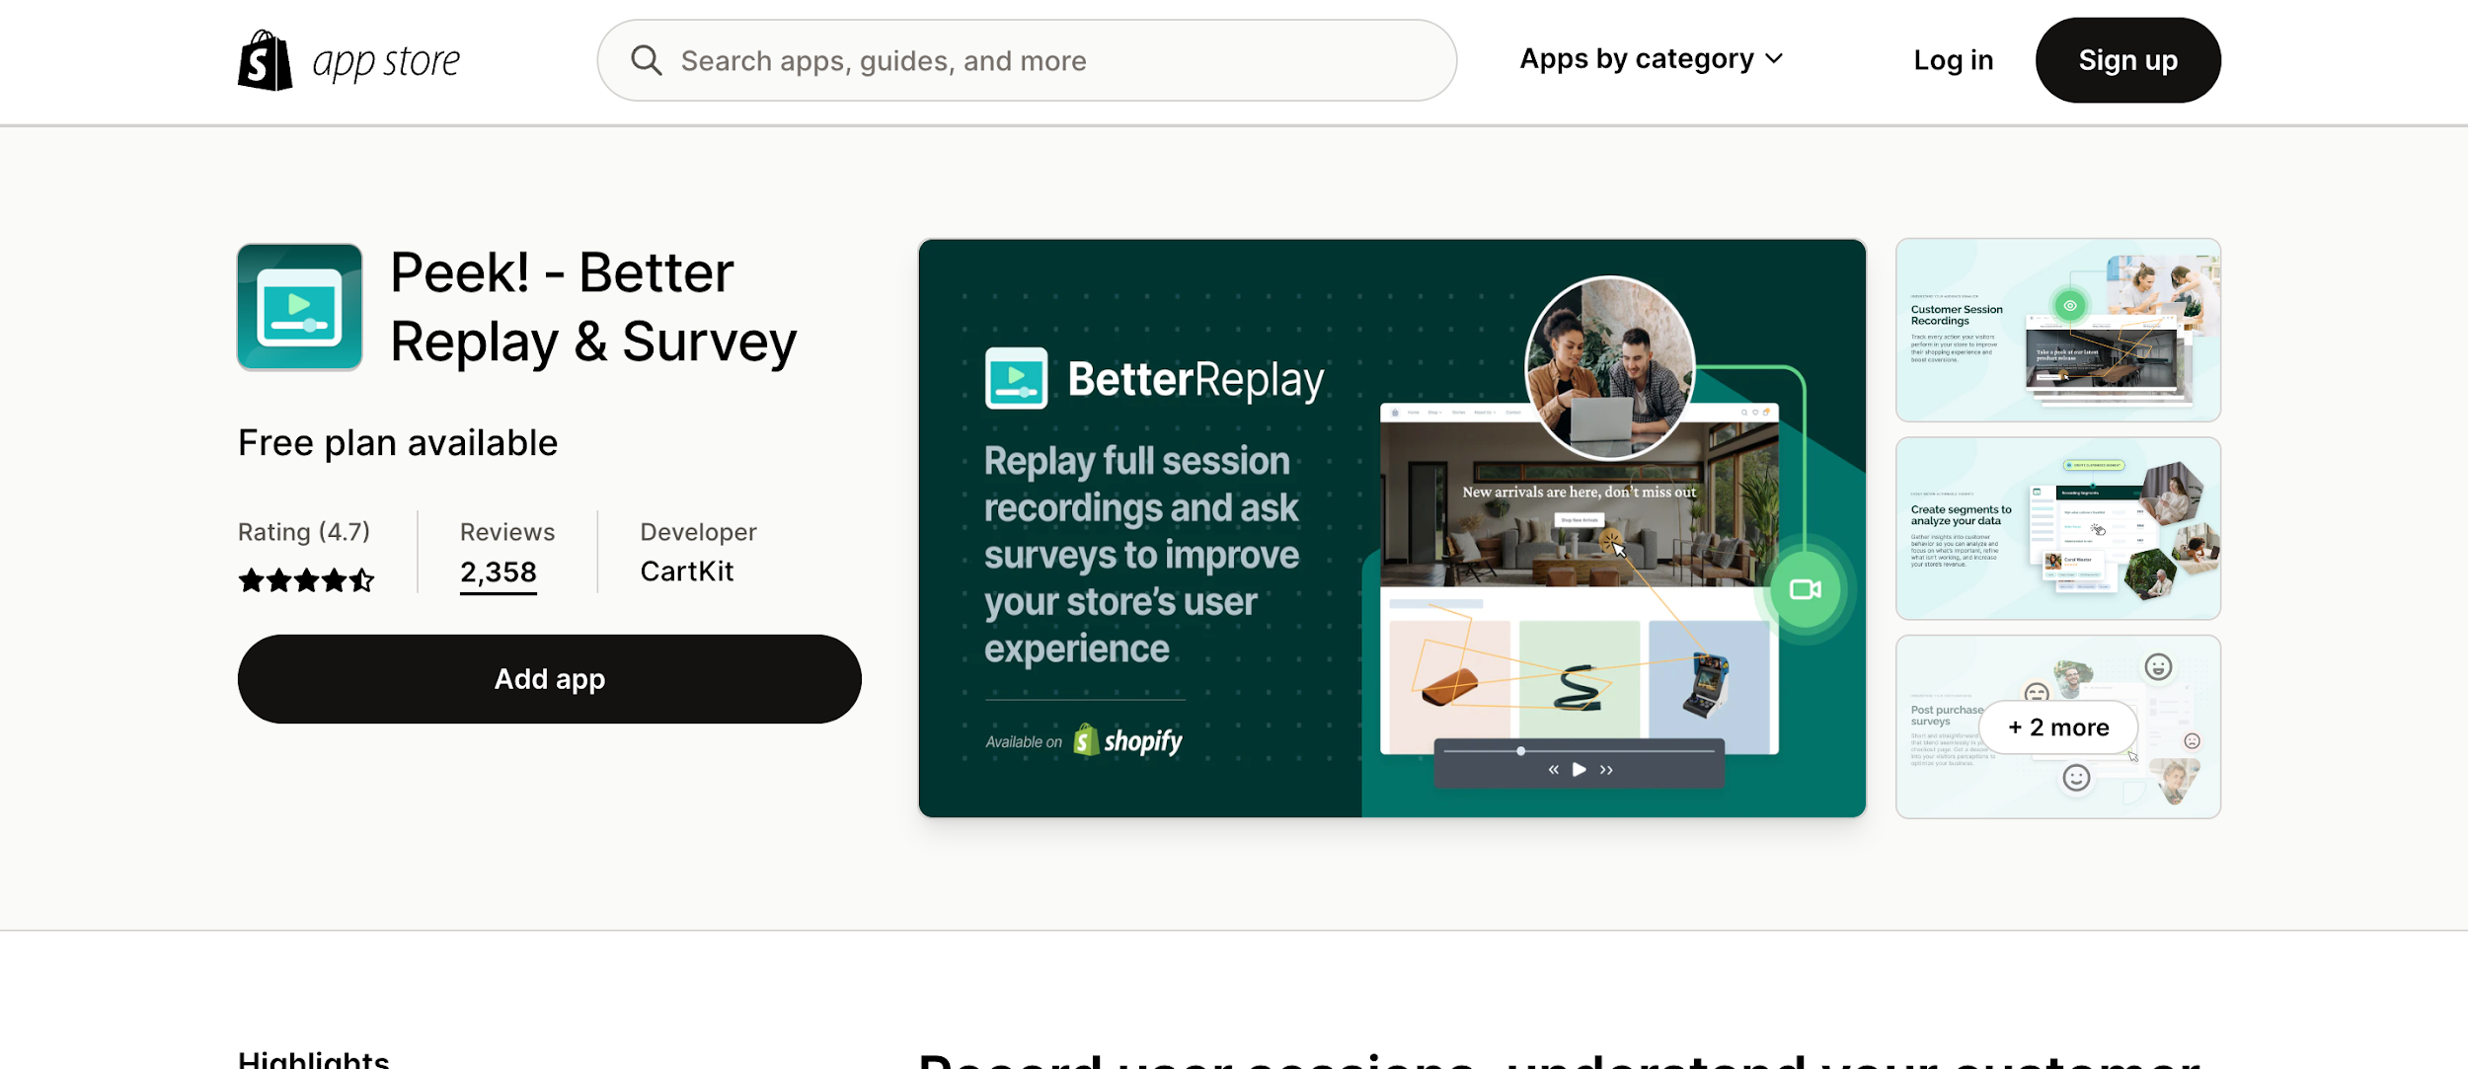
Peek-BetterReplay is an excellent app to let you know about your customers. It also helps increase customer engagement and loyalty. The app sends personalized, automated emails to customers after they've made a purchase.
The emails contain product recommendations tailored to the customer's purchase history, coupon codes, and discounts to encourage repeat purchases. The user-generated content helps in creating interaction between you and your customers.
Besides, the app enables you to convert your audience to your customers. The post-purchase survey is an excellent service for customers' interaction with you. You can quickly develop and promote a discount coupon, run a retargeting campaign to encourage people back to your company, and more by sending out SMS or Facebook Messenger messages.
This free-to-install app provides you with at least 100 visitors per month to your store. So, to increase traffic and sales, you can rely on this app.

TikTok
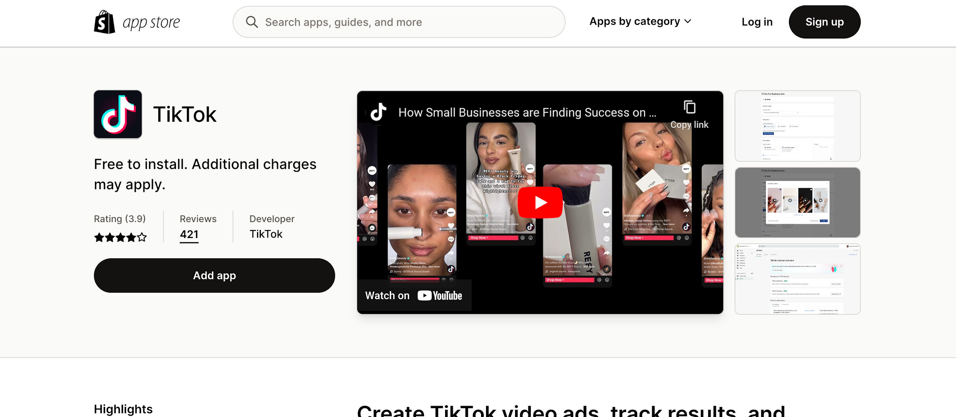
TikTok is currently one of the world's top-listed social media platforms, where business opportunities are increasing daily. The number of people who use TikTok is vast. Most importantly, the engagement of general viewers and business owners is enormous. You can create short videos about your business or any particular product and publish them to the TikTok app.
The app allows merchants to quickly add products and work orders and even promote their business through the platform. You can also customize your online stores to match the look and feel of their brand.
You can also create and manage the campaigns and track performance and analytics. With the TikTok Shopify App, you can take advantage of the platform's broad reach and reach new customers.

Jebbit: Easily Create Quizzes
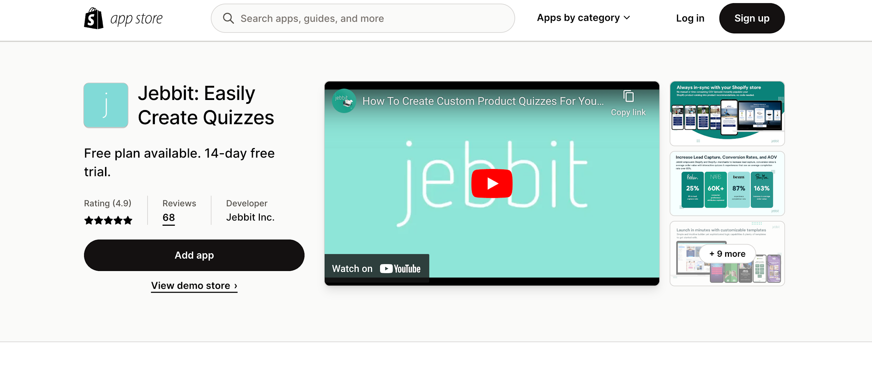
Jebbit Shopify App is an online platform designed to help Shopify store owners create and manage product finder quizzes. With the help of this app, store owners can quickly increase conversion rates, capture leads, and recover abandoned carts without any trace of a code.
It is an easy-to-use and efficient platform that can help store owners maximize their profitability and expand their customer base.
You can update your quizzes and optimize them within just a minute. This app also integrates with Klaviyo & Attentive and builds personalized conversation.
Also give you detailed information about customer interaction, views, engagement, and completion. So, it can increase sales and get the overall opinions of so many essential factors of your online store.

Tip Quik
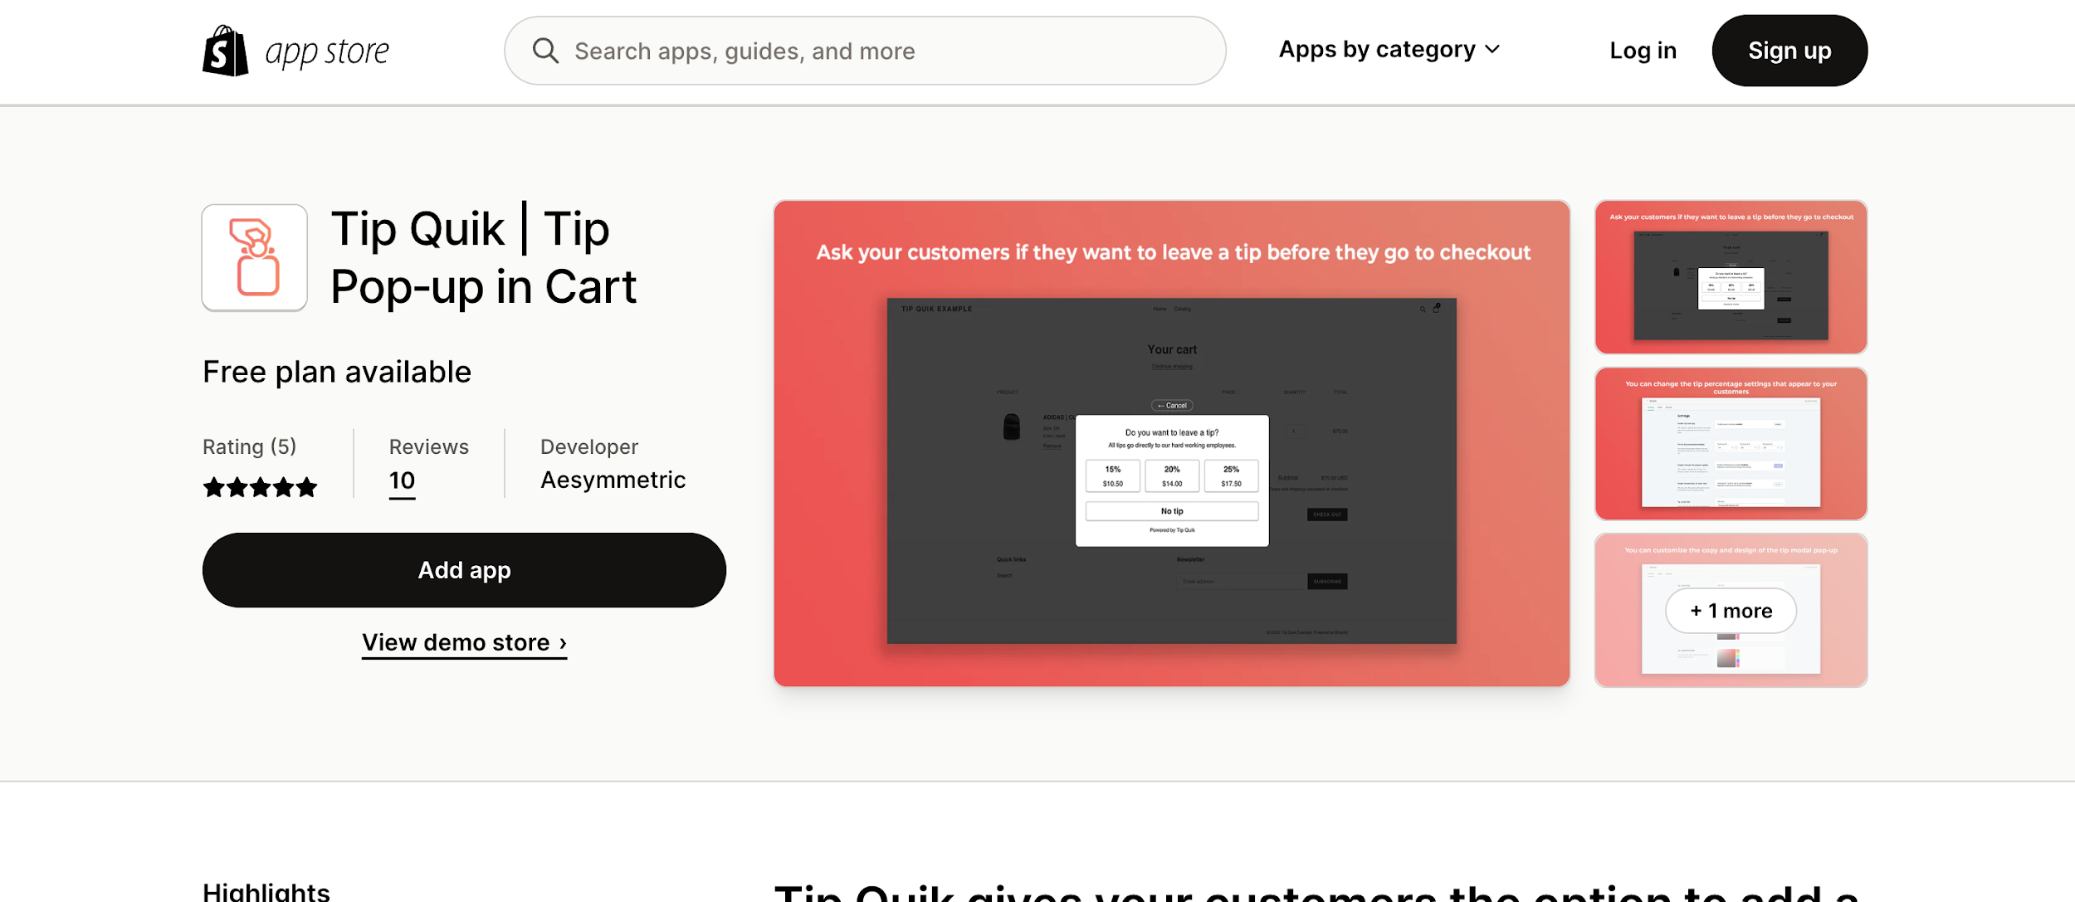
Tip Quik is a great app to make your employees and customers happy. With this app, you can make it easier for customers to pay tips and for businesses to track their sales. It allows your store to add a pop-up system while customers check out.
This pop-up message will appear before the checkout. So, loyal customers can pay tips for your employees. This app also allows you to customize the tip percentage. You can also offer a flat amount as a tip through this app.
Your employees can earn more, and you can also make them happy without cutting your pocket. So, it is a win-win situation for all.

Pre-Order Alpha
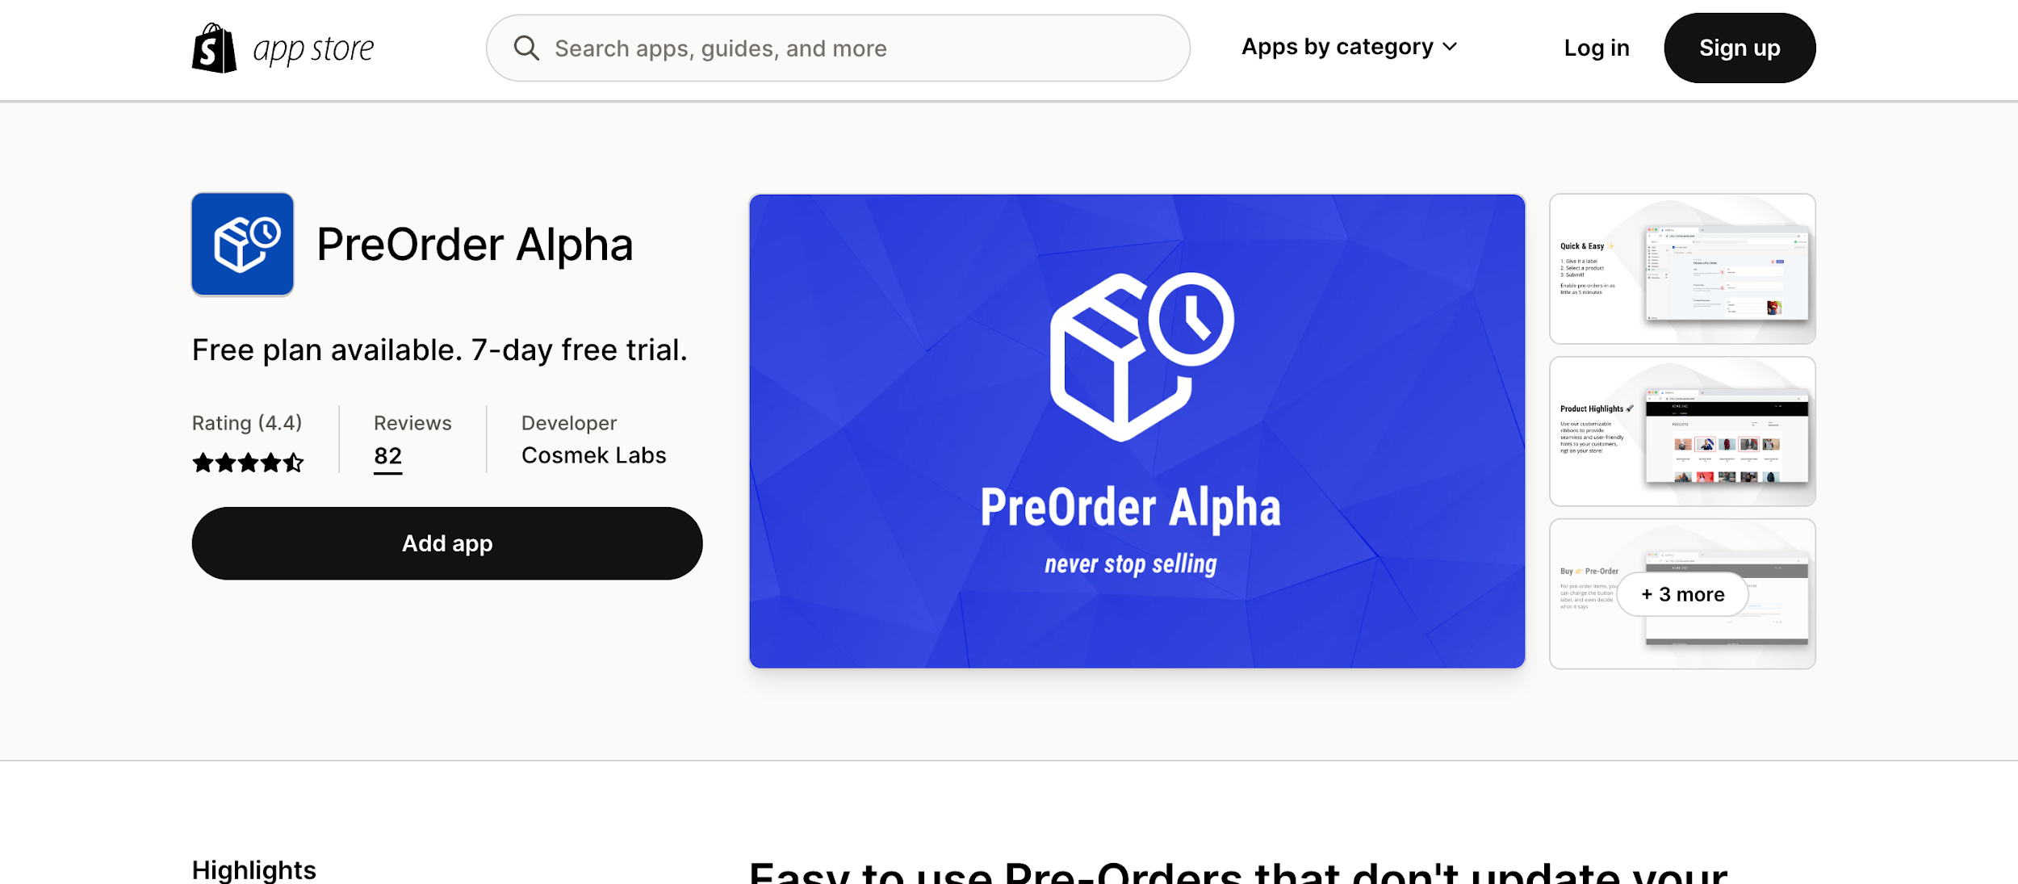
The Pre-Order Alpha app for Shopify allows merchants to add pre-order functionality to their stores quickly. With this app, customers can pre-order items before releasing them and have them delivered to their door on the release day.
This app is easy to use and set up. Merchants can quickly add products to the pre-order page, and customers can pre-order the item.
Besides, you can also show the items on any screens of your store. This free-to-install app provides email notifications, thumbnail badges, order tracking, mixed cart warning, and many other fantastic services.
So, use this app and manage your inventory without investing much money.

Fancy FAQ
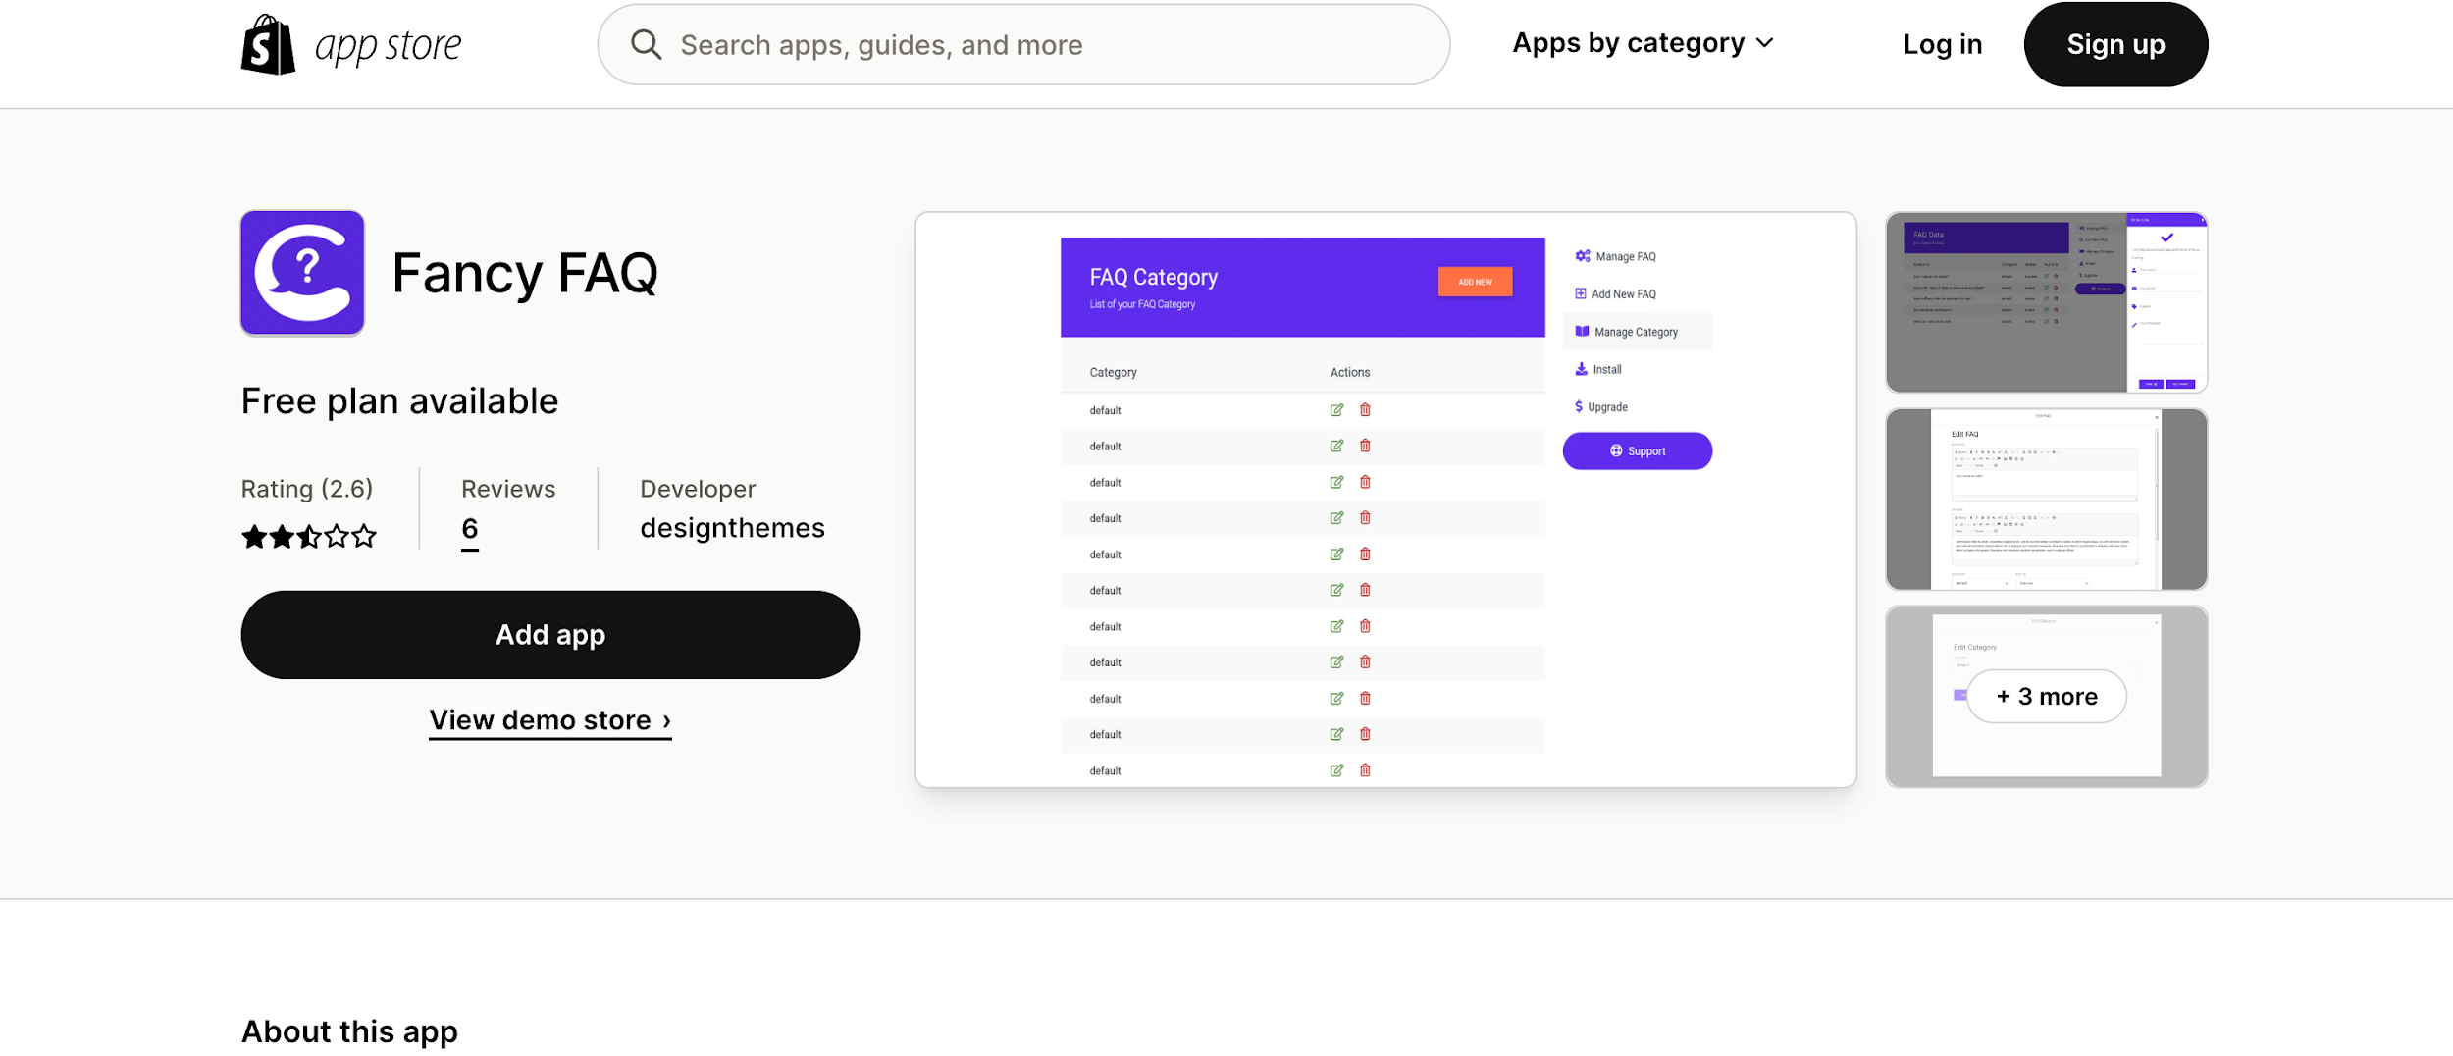
Fancy FAQ (Frequently Asked Questions) helps you create and maintain a comprehensive FAQ section for your online stores. The app makes it easy to create an intuitive and organized FAQ page that customers can quickly navigate.
With its drag-and-drop interface, you can add questions and answers, manage categories, and customize the look and feel of your FAQ page. You can customize the feel and look of the contact form to match your store’s branding.
Its built-in search functionality lets customers quickly find the answers they need. This app also helps you customize the look and feel of your FAQ page and manage customer inquiries.

PixPix Image Editor
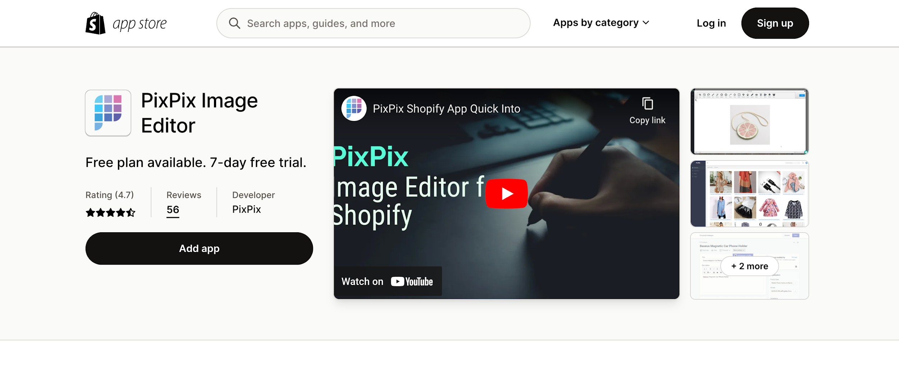
PixPix is an excellent app for adding high-quality images to their store. With PixPix, store owners can quickly and easily find pictures that match their product offerings and customize them with text, graphics, and more.
You can edit the image by cropping, resizing, and so many other fascinating tools to create a lucrative image for your store. Unlike other image editing apps, PixPix is incredibly user-friendly and intuitive.
With just a few clicks, store owners can access a library of thousands of royalty-free stock images, customize them to fit their store's look and feel, and add them to their store with ease.
Store owners can also upload photos or use PixPix's editing tools to adjust existing images. Overall, PixPix is a handy Shopify app that allows store owners to edit images easily for scaling their businesses.

Smart SEO
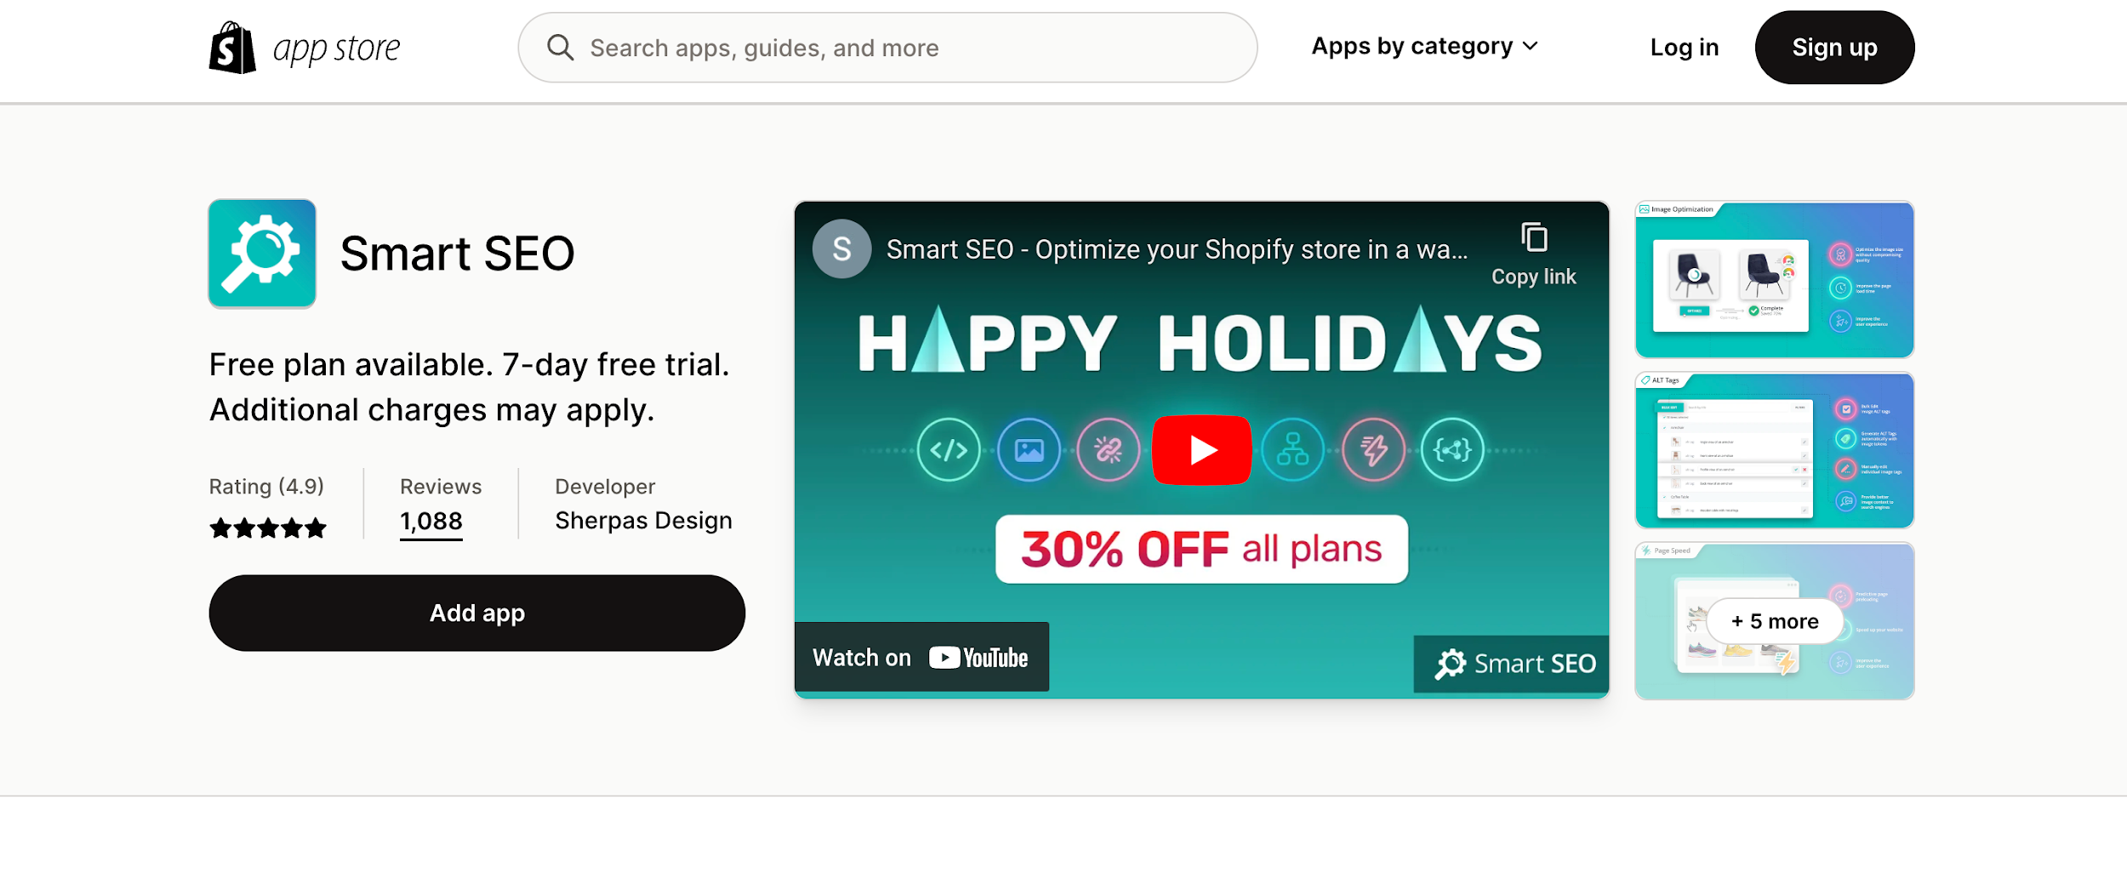
SEO plays a vital role in building interactive online stores. And Smart SEO app can help you achieve that.
This free app helps you improve your visibility in search engine rankings and increase average order value and overall traffic.
Along with advanced search engine optimization, it does keyword research, content optimization, link building, and many more.
Store owners can also track their SEO progress with the app's powerful analytics feature. This app can also detect and fix broken links in your store. So, optimize your store, and rank in Google search results to boost sales.
Smart SEO Shopify App is an invaluable tool for store owners looking to optimize their stores for SEO.

Printful
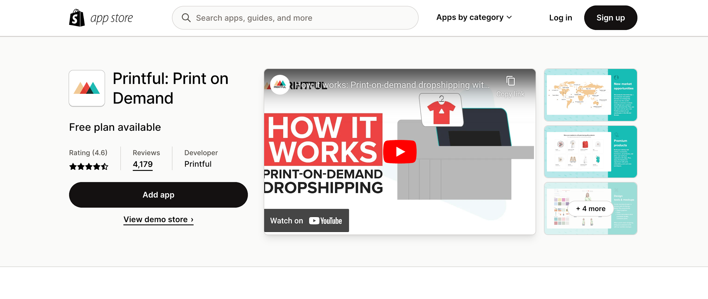
Printful is one of the most popular apps on Shopify that comes for free. You can custom print-on-demand products with this app without any hassle. It allows you to upload your designs or select from an extensive library of artwork, graphics, and logos.
With printful, you can make t-shirts, hoodies, mugs, phone cases, and more with no minimum order quantity. This app integrates with Amazon, eBay, Etsy, and Storenvy, allowing users to add their products to their online store instantly.
With automated fulfillment, Printful handles the entire printing and shipping process, from printing to packaging and shipping. To set up this app, you will need just a few minutes; after that, you can start processing your orders.

Promo.com
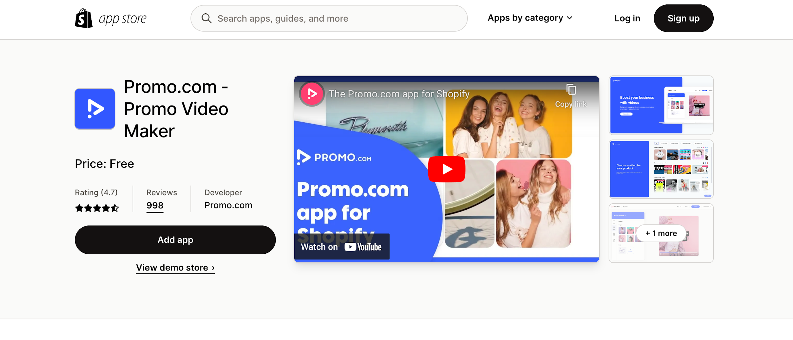
Promo.com is an all-in-one video marketing solution for Shopify store owners. With Promo.com, store owners can create stunning video ads optimized for multiple platforms, including Facebook, YouTube, and Google.
The app also helps store owners easily create promotional videos for their Shopify store, helping them to reach more customers and increase conversions. The app is straightforward, with a drag-and-drop editor that allows users to customize their video ads quickly.
It takes only a minute to make professional ads with this app. With Promo.com, store owners can easily reach more customers, increase sales, and grow their businesses.

FAQs about best free Shopify apps

Are all Shopify apps free?
No, not all Shopify apps are free. Many apps are available for a monthly fee, and some apps may charge a one-time setup fee.

Is Shopify POS app free?
Yes, the Shopify POS app is free to download and use. Shopify POS app has two subscription options. One is Shopify POS Lite, and the other is Shopify POS Pro. Shopify POS Lite comes for free ad available with every Shopify plan. And Shopify POS Pro charges $89 per month along with your Shopify plan.

What apps should I use on my Shopify store?
You can use the following free apps to check which are the best Shopify apps for your business plan and upgrade your app if needed.
- Easy Digital Product
- Automizely Email&SMS Marketing
- EasyShip- All in One Shipping
- Offset
- Advoz
- Peek!-BetterReplay & Survey
- TikTok
- Jebbit: Easily Create Quizzes
- Tip Quik
- Pre-Order Alpha
- Fancy FAQ
- PixPix Image Editor
- Smart SEO
- Printful
- Promo.com

What is the best discount app for Shopify?
The best discount app for Shopify is Bold Discounts. This app lets you quickly and easily create dynamic discounts and promotions on your Shopify store in minutes. It also allows you to customize the discount settings to fit your specific store needs, and its user-friendly interface makes it easy to manage.

What’s Next
Shopify is arguably the world’s most powerful eCommerce platform. The main feature of Shopify is the ability to manage online stores at any level.
The apps listed here will provide everything you need to keep things organized in your Shopify eCommerce store.
So, what are your favorite free Shopify apps? Feel free to share it with us. We will update our list with your suggestion.

